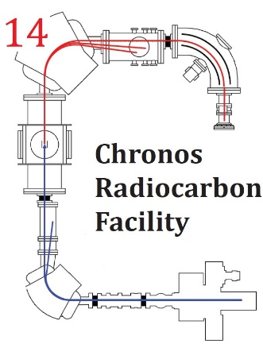
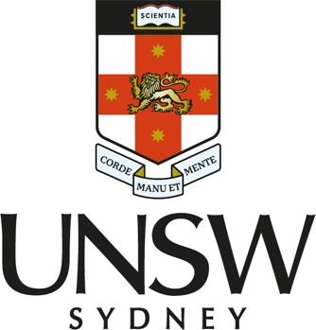

Application for Chronos prize, 2024 AQUA Biennial Meeting

Principal Investigator
Affiliation
Student/staff
Email

AQUA presentation title
Presentation type

Research Project Title

Research Description (how will the radiocarbon dates impact the project?)

Research and funding opportunities (please detail any career breaks etc)

Conditions of entry:

- Must be an AQUA member
- Must be attending AQUA biennial meeting
- Must be presenting at the meeting
- Application must not exceed 2 pages including figures. Please show stratigraphy where possible.
- Applications close 20/06/24
- Offer must be taken up by 30/06/2025

Please return to the Chronos Radiocarbon Facility

Director
A Prof Tim Barrows
t.barrows@unsw.edu.au

