SUPPLEMENTARY MATERIAL: Combined Useries-ESR dating

Contains 5 Tables and 2 Figures following the text.

- Detailed analytical procedure
  - Sample preparation
Dental tissues were mechanically separated and the enamel layer was cleaned on inner and outer sides with a dentist drill to eliminate the volume that received an external alpha dose. Initial and removed enamel thicknesses were measured. The enamel and dentine samples were ground and sieved <200 µm for subsequent bulk ESR and/or U-series analyses.
  - ESR dose evaluation
The ESR dose evaluation was performed at the Centro Nacional de Investigación sobre la Evolución Humana (CENIEH), Spain. Dose evaluation utilised the multiple aliquot additive dose (MAAD) method. The enamel sample #582 was divided into 11 aliquots of ~20 mg each (Table S1). They were irradiated with a Cs-137 gamma source (dose rate = 5.6 Gy/min) to the following doses: 29.2, 58.5, 97.6, 146.4, 195.1, 292.8, 390.3, 487.9, 780.5 and 1463.6 Gy. One aliquot was kept untouched (= natural aliquot).
ESR measurements were carried out at room temperature with an EMXmicro 6/1 Bruker ESR spectrometer coupled to a standard rectangular ER 4102ST cavity. The following procedure was used to minimise the analytical uncertainties: (i) all aliquots of a given sample were carefully weighted into their corresponding tubes and a variation of <1 mg was tolerated between aliquots; (ii) ESR measurements were performed using a Teflon sample tube holder inserted from the bottom of the cavity to ensure that the vertical position of the tubes remains exactly the same for all aliquots. The following acquisition parameters were used: 2-30 scans depending on the aliquot, 1 mW microwave power, 1024 points resolution, 13 mT sweep width, 100 kHz modulation frequency, 0.1 mT modulation amplitude, 20 ms conversion time and 5 ms time constant. This procedure was repeated three to five times over successive days without removing the enamel from the ESR tubes between measurements in order to evaluate measurement repeatability.
The ESR intensities were extracted from T1-B2 peak-to-peak amplitudes of the ESR signal (Grün, 2000a), and then normalised to the corresponding number of scans and aliquot mass. Baseline correction was applied to all spectra with a cubic function using Bruker WinEPR Processing software. High-frequency background noise was evaluated and subtracted as described in Arnold et al., (2024). D_{E} values were obtained by fitting a single saturating exponential (SSE) function (Duval et al., 2009) through the mean ESR intensities derived from the repeated measurements. Fitting was performed with Microcal OriginPro 9.1 software, which is based on a Levenberg-Marquardt algorithm by chi-square minimisation. Data were weighted by the inverse of the squared ESR intensity (1/I²) (Grün and Brumby, 1994) or the inverse of the squared experimental errors (1/s²).
  - Solution U-series analyses
Solution U-series analyses of powdered enamel and dentine were carried out using a Nu Plasma HR MC-ICP-MS in the Radiogenic Isotope Facility (RIF) at the School of Earth and Environmental Sciences, the University of Queensland (Australia), following chemical treatment procedures and MC-ICP-MS analytical protocols described elsewhere (e.g. Zhao et al., 2009; Clark et al., 2014). Powdered sub-samples weighing 1–5 mg were spiked with a mixed ²²⁹Th-²³³U tracer and then completely dissolved in concentrated HNO₃. After digestion, each sample was treated with H₂O₂ to decompose trace amounts of organic matters and to facilitate complete sample-tracer homogenisation. U and Th were separated using conventional anion-exchange column chemistry using Bio-Rad AG 1-X8 resin. After stripping off the matrix from the column using double-distilled 7N HNO₃ as eluent, 3 ml of a 2% HNO₃ solution mixed with trace amount of HF was used to elute both U and Th into a 3.5-ml pre-cleaned test tube. After column chemistry, the U-Th mixed solution was injected into the MC-ICP-MS through a DSN-100 desolvation nebuliser system with an uptake rate of around 0.07 ml per minute. U-Th isotopic ratio measurement was performed on the MC-ICP-MS using a detector configuration to allow simultaneous measurements of both U and Th. Closed-system U-series ages were calculated using the Isoplot/Ex 3.75 Program (Ludwig, 2003).
  - Dose rate evaluation and age calculations
Environmental dose rate was evaluated through a combination of laboratory and in situ measurements. In situ gamma dose rate measurements were performed with a NaI (Tl) probe connected to a Canberra Inspector-1000 multichannel analyser, and processed following Arnold et al. (2012). Inductively Coupled Plasma Mass Spectrometry (ICP-MS) analyses of raw sediment associated to the fossils specimens were performed by Genalysis Laboratory Services: U and Th and K concentrations were obtained after a four-acid digest preparation procedure. The following parameters were used for the dose rate calculations: an alpha efficiency of 0.13 ± 0.02 (Grün and Katzenberger-Apel, 1994), Monte-Carlo beta attenuation factors from Marsh (1999), dose-rate conversion factors from Guérin et al (2011), an estimated water content of 5 ± 3 and 27 ± 5 wt.% in dentine and sediment, respectively. The cosmic dose rate evaluation is extensively detailed below in a dedicated subsection (1.5).
Finally, age calculations were performed with DATA program (Grün, 2009) using the US and model defined by Grün et al (1988), providing a US-ESR age result.
  - Cosmic dose rate evaluation
The cosmic dose rate was estimated following the same approach as in McInerney et al. (2022) which takes into consideration the site altitude, geomagnetic latitude, and geometry of sediment above the sample, as well as an estimate of the long term mean lake level (overlying water column depth). The long-term sediment overburden has been estimated via stratigraphic correlations of the prominent selenite layer found immediately overlying the fossil at the 1893 excavation site (Wells & Tedford, 1995) with that found within a nearby sedimentary reference section that preserves a more comprehensive record of the Late Pleistocene to Holocene lacustrine infilling history for the basin. Using this reference section, we estimate that specimen VII was progressively overlain by up to 3.4 m of sediment overburden during the latter stages of its burial period. A time-averaged sediment overburden thicknesses of 1.7 m has therefore been adopted for calculating the cosmic dose rate of U-series/ESR sample #582, assuming relatively steady deposition of lacustrine sediments over time. Reasonable constraints on the depths of past lake filling episodes are available from the Callabonna-Frome shoreline elevation and time series data presented in Cohen et al. (2015). For the -3 m AHD (Australian Height Datum) lake floor sampling localities at Site 3, past hydrological conditions are known to have ranged from complete (or near complete) absence of a perennial water body, as observed today, to significant lake-full events with water depths up to 24 m, as evidenced by a +21 m AHD shoreline preserved along the southwestern margin of Lake Callabonna. The mid-point lake water depths between these two end-member possibilities (12 m) has therefore been used to derive the time-averaged lake water depth for cosmic attenuation adjustment. To capture the full range of known past lake filling scenarios in our cosmic-ray dose rate calculation, we have assigned a 2σ long-term water depth uncertainty that spans both the minimum and maximum end-member limits (i.e., lake depths of 0 to +24 m).
- Results
  - ESR dose evaluation
ESR measurements of enamel sample #582 were performed with aliquots of about 19.6 mg on average (Table S1). The ESR dose response curve is displayed in Fig. S1. The mean ESR intensities show limited variability over repeated measurements (0.6%), resulting in D_{E} values varying within a narrow range (2.0%).
Single saturating exponential (SSE) dose response curve fitting was initially carried out using mean raw (non-corrected) ESR intensities and over the full dose range (D_{max} = 1464 Gy), yielding a D_{E1} value of 65.2 ± 1.2 Gy. Since the D_{max}/D_{E} ratio (~22.5) exceeds the range of 5-10 recommended by Duval and Grün (2016), a second SSE fitting was carried out after adjusting the D_{max} to 488 Gy, providing a similar (1% higher) dose value (D_{E2}) of 65.6 ± 2.1 Gy (D_{max}/D_{E2} = 7.4). Given the relatively small size of the aliquots (<20 mg) and the young age of the samples, the ESR spectrum of the least irradiated aliquots shows a non-horizontal baseline and a noticeable high-frequency background noise. These complications reflect the weak ESR intensities measured, despite the increased number of accumulated scans used (up to 30). A minimum signal-to-noise ratio (S/N) of 18.3 was calculated (following Arnold et al., 2024) for the sample from for the natural aliquot. In order to evaluate whether these weak intensities impact the reliability of dose evaluation, several additional fittings were carried out. First, a cubic baseline correction was applied with Bruker WinEPR Processing software to all aliquots, resulting in slightly lower ESR intensities of up to 3% for the natural aliquot. SSE fitting carried out using the mean baseline-corrected ESR intensities returns a D_{E3} value of 61.8 ± 2.1 Gy, i.e., slightly lower by about 3% compared to D_{E2}. The high frequency noise was also subsequently subtracted from all ESR spectra following Arnold et al. (2024), lowering the ESR intensities by 1 to 5% depending on the aliquot considered. A fourth SSE fitting was therefore performed through the baseline-corrected and noise-corrected ESR intensities, yielding a D_{E4} value of 61.8 ± 2.1 Gy, which is very close (-3%) to D_{E3}. Finally, SSE fitting was carried out using the same conditions (i.e., using the baseline-corrected and noise-corrected ESR intensities), but with data weighted by 1/s². This approach also returned a very similar (+1%) D_{E5} of 62.7 ± 2.7 Gy. To sum up, the various fitting sensitivity tests show that the dose estimates vary within a very narrow range (< 4 Gy) regardless of D_{max}, baseline-correction or noise-correction considerations, with all results being in agreement at 1σ.
Summarising, the ESR data satisfy a series of quality-assurance criteria (e.g., high measurement repeatability; high goodness-of-fit achieved (adjusted r2 >0.999); absence of significant fitting bias due to excessive D_{max} or variable data weighting options), indicating their reliability and robustness. Age calculations were therefore carried out with the D_{E4} value following Duval and Grün (2016).
  - Solution U-series analyses
Solution U-series analyses return apparent U-series ages of 25.9 and 10.3 ka for the enamel and dentine, respectively (Table S2). These should be regarded as minimum age constraints for the fossil, since uranium uptake may be significantly delayed after the death of the animal. Additionally, the absence of apparent uranium leaching and the low uranium concentration measured in the enamel (<0.5 ppm) make the tooth suitable for the application of the combined U-series/ESR dating approach (Duval et al., 2012).
  - Dose rate evaluation
As detailed earlier, it was not possible to obtain directly associated in situ gamma dose rate measurements for #582, since the fossil specimen was collected in 1893 and the excavation area no longer exists. However, several sediment samples were collected directly from the paleontological collections, i.e., SED-1 to SED-7 associated with M1 and M2 teeth of specimen VII, and related bones from the same excavation (SED-3) (Table S3). Radioelement concentration values measured from these sediment samples show significant variability (U: 42.9%; Th: 100.6 %; K: 51.6%). In particular, the two samples from the dated tooth (SED-1 and SED-2) provide very high Th concentrations compared with the other samples, including those obtained using in situ gamma spectrometry for related deposits at Site 3 (Table S4). This variability may cast reasonable doubt on the appropriateness of using any other sediment samples than those directly associated with the dated tooth for the dose rate evaluation (i.e., SED-1 and SED-2, which are the only sediment samples that were directly attached to the tooth being dated). However, the very small amount of material analysed for these two samples (6-12 mg) may not only limit the reliability of the resultant radioelement values, but also raise questions about their representativeness of the original sedimentary environment surrounding the tooth.
Gamma dose rate calculations using either field or laboratory measurements (Tables S4 and S5) return values ranging values from 497 ± 21 to 924 ± 43 µGy/a (Table S5). These extreme end-member values were obtained from the sediment attached to the fossils, by considering either all samples together to derive a minimum value (SED-1 to SED-7) or only the two samples directly collected from the dated tooth (SED-1 and SED-2). In comparison, the in situ dosimetry measurements made on similar fossil-bearing lacustrine sediments elsewhere at Site 3 yield intermediate gamma dose rate values of 618 ± 34 to 734 ± 38 µGy/a (Table S5), depending on the subset of measurements considered.
  - Combined U-series and ESR age calculations
An initial combined U-series/ESR age calculation performed with the beta dose rate from the sediment attached to the tooth (SED1-2) and the gamma dose rate from the in situ measurements of LC14-18 returns a US-ESR age of 72 ± 4 ka (Scenario A in Table 3). The total dose rate is largely dominated by the gamma+cosmic component (87%), while the dental tissues represent <5% of the combined dose rate. In other words, the sedimentary environment (beta and gamma components) accounts for ~90 % of the total dose rate, and thus the reliability of the final age will be significantly dependent on the representativeness of the sediment dose rate evaluations. Consequently, the apparent US-ESR age estimate should be treated with extreme caution given the significant uncertainty associated with the exact stratigraphic position of the teeth collected in 1893 and the impossibility of obtaining a directly associated in situ gamma dose rate for the dated tooth. Importantly, the use of the CSUS model (Grün, 2000b) has virtually no impact on the calculated ages, which differ by < 1 ka compared to the initial US-ESR estimates obtained for both scenarios A and B, indicating that the uncertainty on the dose rate modelling is negligible here.
The two sediment samples collected directly from the tooth show much higher natural radioactivity when compared to the in situ measurements performed elsewhere at Site 3, and it cannot be excluded that the latter may not be fully representative of the true gamma dose rate experienced by the dated tooth sample at the 1893 site. Consequently, an alternative combined U-series/ESR calculation was performed using sediment samples SED-1 and SED-2 for both the beta and gamma dose rate evaluation, which yielded an age of 55 +5 /-4 ka (Scenario B in Table 3). This more conservative option potentially provides a more accurate age estimate since it is based on the sediment directly attached to the M2 tooth. Age sensitivity tests performed with long-term water contents varying by ± 2-3% or ± 7-8% compared with the initial value of 27 % only modify the US-ESR estimate of 55 ka by ± 4% (i.e., ± 2 ka) and ± 9-13% (i.e., ± 5-7 ka), respectively. In other words, the final age remain within error, illustrating the limited impact of our long-term water content assumptions on the dating results.
Despite the robustness of the ESR data collected for sample #582, we cannot exclude the possibility that non-negligible high-frequency background noise in the least-irradiated aliquots (S/N = 18.3 for the natural aliquot; see an example in Fig. S2A) may bias the evaluation of the ESR intensity, and thus the dose determination. Consequently, alternative correction procedures were employed to reduce this noise and evaluate the extent to which the resulting US-ESR age might be impacted. In particular, fast Fourier transforms (FFTs) were used via WinEPR to represent the ESR spectra in frequency domains (Fig. S2B). Interestingly, main signal frequencies (<0.4 1/G) show little variability across aliquots, confirming that the same radiation-induced ESR signal has been recorded in all aliquots, regardless of the proportion of noise observed. Two types of window functions (Gaussian and Hamming) were tested with more or less conservative parameters in order to correct the spectra and remove the noise without impacting signal intensity (see example Fig. S2B). The resulting D_{E} values vary by about < 2.5 Gy and range from 59.5 to 62.0 Gy (Fig. 2C). These values are < 3% lower than the D_{E4} values used for age calculation (Table S1) and are systematically within error of the value initially calculated after subtracting the background noise (following the procedure described in Arnold et al., 2024). These alternative D_{E} estimates would result in a slightly younger age of up to 53 +4 -3 ka. Consequently, these results show that all noise correction and subtraction procedures return very similar results, confirming that the high frequency background noise has only a very limited impact on the resulting age estimates.
- Summary
Given that the surrounding sediment environment of the fossil tooth dominates its total dose rate (~90 %), the inability to perform directly associated gamma dose rate evaluations poses a significant problem for deriving a reliable age for sample #582. This is further complicated by significant variability in the radioelement concentrations of bulk sediment samples associated with the fossil material from the 1893 excavation collections. Other potential sources of uncertainty, such as assumptions about the long-term water content of the sediment or evaluations of background noise affecting the ESR spectra, appear to have much more limited impacts on the final US-ESR ages. Notwithstanding major caveats in the environmental dose rate calculation, we consider the US-ESR age of 55 +5 /-4 ka (Scenario B in Table 3) as the most secure estimate of the true fossil age, since it is at least based on dose rate evaluations of sediment directly attached to the M2 tooth. The reliability of this US-ESR age is supported by its agreement with two single-grain OSL ages of 54.2 ± 3.8 to 50.4 ± 3.5 ka (1σ uncertainties) obtained for sediment samples associated with other extinct megafaunal remains (Genyornis newtoni) at nearby Lake Callabonna sites (Site 4 and Site 7; McInerney et al., 2022). However, additional trapped charge dating assessments of other Diprotodon fossil specimens from Site 3, undertaken in conjunction with more representative in situ dose rate evaluations, are needed to establish a more secure chronological framework for the extinct megafauna preserved in this part of the Lake Callabonna basin.

Table S1. Detailed ESR results obtained for #582. Measurement precision is expressed as the mean coefficient of variation obtained for all the aliquots of a given sample after the two repeated measurements. D_{E} precision is the variation of the D_{E} values derived from the repeated measurements of a given sample (derived from the non-corrected ESR intensities). D_{E1} was obtained by fitting a single saturating exponential (SSE) function (with data weighting by the inverse of the squared signal intensities; 1/I²) through the raw ESR signal intensities over the full range of the dose response curve (maximum dose or D_{max} = 1459 Gy). D_{E2} was calculated in the same manner except the dose response curve fitting was performed over a lower maximum dose range (D_{max} = 488 Gy) in order to satisfy the D_{max}/D_{E} ratio recommendations of Duval & Grün (2016). D_{E3} was obtained using the same fitting constraints as D_{E2}, but the dose response curve was constructed using baseline-corrected ESR intensities (baseline correction was carried out with WinEPR System software using a cubic function). D_{E4} were obtained using the same fitting constraints as D_{E3}, but the dose response curve was constructed using baseline-corrected and noise-subtracted (see explanation in Arnold et al., 2024) ESR intensities. D_{E5} was calculated in the same manner as D_{E4}, with the exception that the dose response curve was fitted using a SSE function with data weighting equal to the inverse of the squared relative uncertainty of each dose point (1/s²) rather than 1/I². Uncertainties are given at 1σ.

Sample | #582
Average weight per aliquot (mg) | 19.6 ± 0.3
Number of repeated measurements | 2
Mean ESR intensity precision (%) | 0.6
SSE fitting (data weighting by 1/I²)
Non-corrected ESR intensities
D_{max} (Gy) | 1464
D_{E} precision (%) | 2.0
Adj. r-Square | 1.000
D_{E1} (Gy) | 65.2 ± 1.2
D_{max}/D_{E} | 22.4
D_{max} (Gy) | 488
Adj. r-Square | 0.999
D_{E2} (Gy) | 65.6 ± 2.1
D_{max}/D_{E2} | 7.4
Baseline-corrected ESR intensities
D_{max} (Gy) | 488
Adj. r-Square | 0.999
D_{E3} (Gy) | 63.7 ± 2.1
D_{max}/D_{E3} | 7.7
Baseline-corrected and noise-subtracted ESR intensities
D_{max} (Gy) | 488
Adj. r-Square | 0.999
D_{E4} (Gy) | 61.8 ± 2.1
D_{max}/D_{E4} | 7.9
SSE fitting (data weighting by 1/s²)
Baseline-corrected and noise-subtracted ESR intensities
D_{max} (Gy) | 488
Adj. r-Square | 0.999
D_{E5} (Gy) | 62.7 ± 2.7
D_{max}/D_{E5} | 7.8
D_{E} ratios
D_{E2}/D_{E1} ratio | 1.01
D_{E3}/D_{E2} ratio | 0.97
D_{E4}/D_{E3} ratio | 0.97
D_{E5}/D_{E4} ratio | 1.01

Table S2. U-series data obtained from solution ICP-MS analyses of the powdered dental tissues. The activity ratios enclosed in parentheses are derived from atomic ratios but normalised to measured values of secular-equilibrium HU-1 (Ludwig et al. 1992); errors are indicated at the 2σ level. Calculations of ²³⁰Th ages were conducted using Isoplot EX 3.0 (Ludwig 2003), with specific decay constants provided for ²³⁸U (λ₂₃₈ = 1.551x10⁻¹⁰ yr⁻¹), ²³⁴U (λ₂₃₄ = 2.826 x10⁻⁶ yr⁻¹), and ²³⁰Th (λ₂₃₀ = 9.158x10⁻⁶ yr⁻¹) following Cheng et al. (2000). The 2σ errors associated with the uncorrected ages stem directly from uncertainties in the ²³⁰Th/²³⁸U and ²³⁴U/²³⁸U ratios. The corrected ²³⁰Th age is determined based on an assumed bulk Earth or upper crust value of 0.83.
Sample ID | Tissue | U (ppm) | ²³⁰Th/ ²³²Th | ²³⁰Th/²³⁸U | ²³⁴U/ ²³⁸U | uncorr. ²³⁰Th age (ka) | corr.  ²³⁰Th age (ka) | corr. Initial (²³⁴U/ ²³⁸U)
#582 | Dentine | 1.513  ± 0.003 | 112.3 | 0.1318  ± 0.0007 | 1.4429  ± 0.0035 | 10.4 ± 0.1 | 10.3 ± 0.1 | 1.4565  ± 0.0036
 | Enamel | 0.224  ± 0.001 | 7.2 | 0.3473  ± 0.0067 | 1.4790  ± 0.0055 | 28.8 ± 0.6 | 25.9 ± 1.4 | 1.5366  ± 0.0126

Table S3. Radioelement concentrations measured in the various sediment samples. Key: s.d. = standard deviation; c.v. = coefficient of variation.

Sample ID | Fossil | Weight (mg) | U (ppm) | Th (ppm) | K (%)
SED-1 | M2 (specimen VII) | 6 | 1.69 ± 0.09 | 25.05 ± 1.05 | 1.04 ± 0.04
SED-2 | M2 (specimen VII) | 12 | 0.98 ± 0.08 | 16.24 ± 0.68 | 0.50 ± 0.02
SED-3 | Bones (1893 site) | 204 | 1.94 ± 0.10 | 7.66 ± 0.32 | 1.31 ± 0.05
SED-4 | M1 (specimen VII) | 39 | 0.84 ± 0.07 | 3.45 ± 0.15 | 0.61 ± 0.02
SED-5 | M1 (specimen VII) | 51 | 0.74 ± 0.07 | 3.47 ± 0.15 | 0.63 ± 0.02
SED-6 | M1 (specimen VII) | 49 | 0.64 ± 0.07 | 2.73 ± 0.12 | 0.44 ±0.02
SED-7 | M1 (specimen VII) | 42 | 1.30 ± 0.08 | 2.19 ± 0.10 | 0.31 ± 0.01
Mean ± 1 s.d.  (c.v.) |  |  | 1.16 ± 0.50 (42.9%) | 8.68 ± 8.74 (100.6%) | 0.69 ± 0.36 (51.6%)

Table S4. Radioelement concentrations (dry values) measured using in situ gamma-ray spectrometry and water contents of host sediments associated with Diprotodon fossils found elsewhere at Site 3. These data have been collected as part of an ongoing, independent OSL dating study taking place at Lake Callabonna.
OSL sample name | location /  association | Moisture  (% dry weight) | U (ppm) | Th (ppm) | K (%)
LC18-1 | site 3 CB2018-8 | 45.0 | 3.80 ± 0.25 | 9.69 ± 0.57 | 1.40 ± 0.08
LC18-2 | site 3 CB2018-8 | 45.6 | 2.22 ± 0.18 | 9.02 ± 0.54 | 1.35 ± 0.07
LC18-3 | site 3 CB2018-14 | 43.7 | 2.05 ± 0.17 | 8.30 ± 0.50 | 1.12 ± 0.06
LC14-6 | site 3 bluff trench | 32.2 | 1.91 ± 0.16 | 7.75 ± 0.47 | 1.10 ± 0.06
LC14-7 | site 3 bluff trench | 28.6 | 2.12 ± 0.16 | 7.50 ± 0.45 | 1.03 ± 0.06
LC14-8 | site 3 bluff trench | 35.7 | 1.92 ± 0.16 | 8.89 ± 0.53 | 1.34 ± 0.07
Mean values
LC18 mean | site 3 CB2018 fossils | 44.7 | 2.69 ± 0.20 | 9.00 ± 0.54 | 1.29 ± 0.07
LC14 mean | site 3 bluff trench | 32.2 | 1.99 ± 0.17 | 8.04 ± 0.50 | 1.16 ± 0.06
combined mean | site 3 | 38.5 | 2.34 ± 0.16 | 8.52 ± 0.47 | 1.22 ± 0.06

Table S5. Gamma dose rate values calculated from the laboratory analyses and in situ measurements. Calculations were performed using dose rate conversion factors from Guérin et al. (2011) and a water content of 27% (% wet weight).
Data inputs | Gamma dose rate (µGy/a)
LC18 in situ measurements (n=3) | 734 ± 38
LC14 in situ measurements (n=3) | 618 ± 34
LC14-LC18 in situ measurements (n=6) | 671 ± 32
SED1-2 | 924 ± 43
SED1-7 | 497 ± 21

Figure S1. ESR dose response curves obtained for #582. A and B: SSE fitting (1/I²) through non-corrected ESR intensities with D_{max} = 1464 Gy (D_{E1}) and D_{max} = 488 Gy (D_{E2}); C: SSE fitting (1/I²) through baseline-corrected ESR intensities with D_{max} = 488 Gy (D_{E3}); D SSE fitting (1/I² and 1/s²) through baseline-corrected and noise-subtracted ESR intensities with D_{max} = 488 Gy (D_{E4} and D_{E5}). Numerical values are given in Table S1. Noise subtraction and baseline correction were performed following Arnold et al. (2024) (see text for further details).
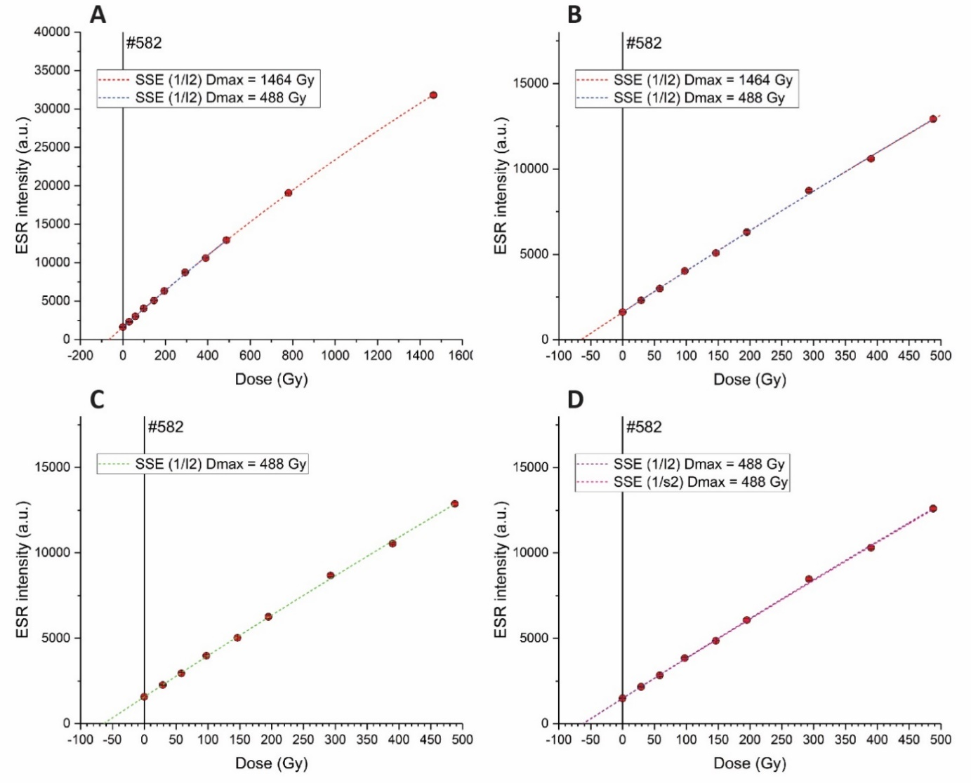

Figure S2. ESR data collected from the measurement of the enamel sample #582. A: example of ESR spectrum (D = 146 Gy) before and after FFT correction (Gaussian window function); B: FFT-transformed spectra obtained for all aliquots of enamel sample #582; C: Comparison of the dose estimates obtained using different noise correction procedures. All results are based on baseline-corrected ESR spectra. Fitting was performed with a SSE (data weighting by 1/I²) up to a D_{max} of 488 Gy. #1 and #2 correspond to D_{E3} and D_{E4} (Table S1), and #3 to #5 were obtained from the use of a Gaussian window function, while a Hamming function was employed for #6 to #8. These functions were adjusted using more or less conservative parameter values (conservative values: #4 and #7; extreme values: #5 and #8; intermediate values: #3 and #6).
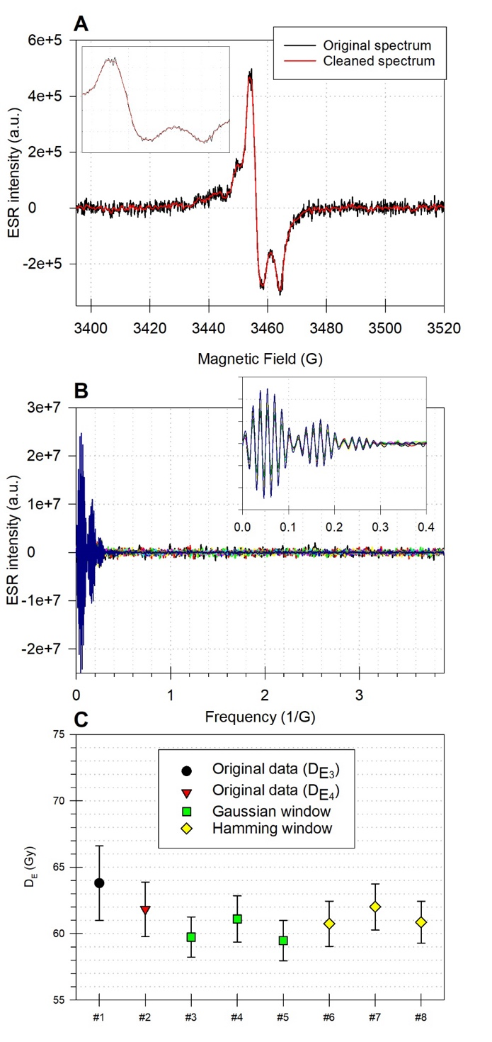

References for Supplementary Data:
Arnold, L.J., Duval, M., Falguères, C., Bahain, J.-J., Demuro, M. (2012). Portable gamma spectrometry with cerium-doped lanthanum bromide scintillators: Suitability assessments for luminescence and electron spin resonance dating applications. Radiation Measurements 47, 6-18.
Arnold, L.J., Demuro, M., Duval., Grün, R., Sanz, M., Costa, A.M., Araújo, A.C., Daura, J. (2024). Single-grain luminescence and U-series/ESR dating of the early Upper Palaeolithic Lagar Velho Rock Shelter. Quaternary Geochronology 83, 101572.
Cheng, H., Edwards, R.L., Hoff, J., Gallup, C.D., Richards, D.A., Asmerom, Y. (2000). The half-lives of uranium-234 and thorium-230. Chemical Geology 169(1-2), pp.17-33.
Clark, T. R., Roff, G., Zhao, J-x., Feng, Y-x., Done, T.J., Pandolfi, J.M. (2014). Testing the precision and accuracy of the U-Th chronometer for dating coral mortality events in the last 100 years. Quaternary Geochronology 23, 35–45.
Cohen, T.J., Jansen, J.D., Gliganic, L.A., Larsen, J.R., Nanson, G.C., May. J-H, Jones, B.G., Price, D.M. (2015). Hydrological transformation coincided with megafaunal extinction in central Australia. Geology 43(3): 195–198. https://doi.org/10.1130/G36346.1
Duval, M. and Grün, R. (2016). Are published ESR dose assessments on fossil tooth enamel reliable? Quaternary Geochronology 31, 19-27.
Duval, M., Falguères, C., Bahain, J.-J. (2012). Age of the oldest hominin settlements in Spain: Contribution of the combined U-series/ESR dating method applied to fossil teeth. Quaternary Geochronology 10, 412-417.
Grün, R. (2000a). Methods of dose determination using ESR spectra of tooth enamel. Radiation Measurements 32(5–6), 767-772.
Grün, R. (2000b). An alternative model for open system U-series/ESR age calculations: (closed system U-series)-ESR, CSUS-ESR. Ancient TL 18(1): 1-4.
Grün, R. and Brumby, S. (1994). The assessment of errors in past radiation doses extrapolated from ESR/TL dose-response data. Radiation Measurements 23(2–3): 307-315.
Ludwig, K.R. (2003). User’s manual for Isoplot/Ex, Version 3.0, A geochronological toolkit for Microsoft Excel, Berkeley Geochronology Center Special Publication. Berkeley, California, USA.
Ludwig, K.R., Simmons, K.R., Szabo, B.J., Winograd, I.J., Landwehr, J.M., Riggs, A.C., Hoffman, R.J. (1992). Mass-spectrometric ²³⁰Th-²³⁴U-²³⁸U dating of the Devils Hole calcite vein. Science, 258(5080), 284-287.
McInerney, P.L., Arnold, L.J., Burke, C., Camens, A.B., Worthy, T.H. (2022). Multiple occurrences of pathologies suggesting a common and severe bone infection in a population of the Australian Pleistocene giant, Genyornis newtoni (Aves, Dromornithidae). Papers in Palaeontology 8, e1415.
Zhao, J-X, Yu, K-F., Feng, Y-X. (2009). High-precision ²³⁸U-²³⁴U-²³⁰Th disequilibrium dating of the recent past: A review. Quaternary Geochronology 4, 423–433.

