SUPPLEMENTARY SECTION
Do late MIS 6 lake sediments at Lorinna, Tasmania indicate damming of the River Forth during the MIS 6 / MIS 5e transition?
McIntosh, P.D.,¹ Schaarschmidt, M.,² Slee, A.J.,¹ Lian, O.B.,² and Neudorf, C.M.³
¹Forest Practices Authority, Tasmania, Australia.
²University of the Fraser Valley, Abbotsford, British Columbia, Canada.
³Vicus Pty Ltd., Rocklea, Queensland, Australia.

Optical dating
Sample preparation and dosimetry
All samples were prepared using standard procedures (Wintle 1997) at the Luminescence Dating Laboratory at the University of the Fraser Valley, Abbotsford, B.C., Canada. All were wet-sieved, using mesh sizes of 250 μm and 180 μm to isolate the desired grain size fraction. Samples were then treated with HCl acid to remove any carbonates that might be present in the sediments. Minerals were then separated by density using heavy liquid (Lithium-Metatungstate) that can be diluted to specific densities. Heavy minerals were isolated using a density of 2.7 g/cm³, and quartz was subsequently separated at a density of 2.62 g/cm³. The isolated quartz grains were then washed with 50% HF acid for 45 min to dissolve any remaining feldspar grains and to etch the outer alpha-irradiated layer (∼5-9 µm).
Water contents of all samples were measured using small, perforated plastic cubes (∼1 cm³) that were pressed into the sediment sample while still in the sample tube to preserve the structure of the sediment. Both, the empty cube, and the sediment filled cube were weighed before it was submerged in water until fully saturated (mass does not increase anymore). Once saturation was achieved, the lid was removed from the sediment-filled cube and the sample cube, and the lid were placed in a drying oven at 50°C and weighed regularly until fully dry (mass does not decrease anymore). To calculate the water content, the mass of the water was divided by the mass of the dry sediment and multiplied by 100 to get the water content in percent. An error of 10% was assigned to all water content values to account for pore water fluctuations over time while buried in the landform.
Radionuclide contents of U, Th and K were determined using Neutron Activation Analysis (NAA) on ∼10 g of dried and milled representative bulk sediment of each sample (Table S1). The cosmic-ray dose rate was calculated taking parameters such as Latitude, Longitude, Altitude, Depth below ground surface and water content into account (Table 1). Final dose rates (cosmic-ray and total dose rate) were determined using the Luminescence Dose and Age Calculator (LDAC v1.0) software (Liang and Forman 2019). Appropriate conversion and attenuation factors were used (Brennan 2003, Guérin et al. 2011).

Table S1: Results of the NAA analysis of dried and milled bulk sediment for all samples.
Sample | K [%] | U [ppm] | Th [ppm]
Lorinna | 1.03 ± 0.07 | 1.95 ± 0.15 | 7.59 ± 0.45

Sample measurements
All luminescence measurements were made on a Risø TL/OSL DA-20 reader containing a ⁹⁰Sr/⁹⁰Y source (average dose rate over measurements period was 4.34-4.37 Gy/min). Luminescence was detected by an Electron Tube PDM 9107Q-AP-TTL-03 photomultiplier tube mounted behind a combination of 5 mm and 2.5 mm-thick Hoya U-340 optical filters. Aliquots were stimulated by blue light at 56 mW/cm² for 100 s while being held at 125°C.
An Equivalent dose (D_{e}) value for each aliquot (50-100 grains per aliquot) was determined by repeatedly measuring and dosing it using the single aliquot regenerative-dose (SAR) protocol (Murray and Wintle 2000, 2003). Quality assurance tests are built into the measurement sequence (i.e., tests to check for sensitivity changes and recuperation (Murray and Wintle 2000)). Table S2 shows the SAR protocol used to determine D_{e} values for all Christmas Hill samples, including an IR wash before each blue stimulation to reduce signals from potential feldspar contamination. For each aliquot the first 0.1 seconds of the signal, with the last 20 s subtracted, was used to construct dose-response curves onto which the natural signal was interpolated to find the D_{e} value.

Table S2: SAR protocol for Lorinna quartz sample. All steps of the protocol constitute one SAR cycle. Ln = natural signal, Lx= regenerative dose signal. Tn = test dose signal measured after Ln, Tx = test dose signal measured after Lx. The first SAR cycle measures the sensitivity corrected natural signal, and subsequent SAR cycles measure the Lx/Tx value after a series of successively increasing laboratory radiation doses (regeneration doses) administered to the sample. The regeneration doses are used to generate a dose-response curve onto which the natural signal (Ln/Tn) is plotted to calculate the De value. Regeneration doses include: 1) one “zero- dose” point where no radiation dose is given to check for recuperation and 2) one “repeat-dose” point, where a previous regeneration dose is given a second time to perform a recycling ratio test.
Step | Procedure | Measured
1 | Natural/Regenerative dose | ∼45-425 Gy
2 | Preheat (220º C, 10 s)
3 | IR stimulation (50ºC, 100 s at 130 mW/cm³) |  | IR wash
4 | Blue stimulation (125º C, 100 s at 56 mW/cm²) | L_{n} or L_{x}
5 | Test dose | ∼5 Gy
6 | Preheat (160º C, 10 s)
7 | IR stimulation (50º C, 100 s at 130 mW/cm³) |  | IR wash
8 | Blue stimulation (125 ºC, 100 s at 56 mW/cm²) | T_{n} or T_{x}
9 | Return to step 1

The suitability of the protocol and measurement conditions were tested in a pilot study where 10 aliquots were measured using the protocol shown in Table S2. Analysis of the data showed bright, fast-decaying luminescence signals (i.e., the desired ‘fast component’ of the signal was dominate in all aliquots measured).
To ensure the sample can reproduce a given dose using the chosen SAR protocol, a dose recovery test was performed on 10 aliquots. Aliquots (50-100 grains per aliquots) were bleached in natural direct sunlight for 30 min and then given a laboratory dose close to the expected natural dose (∼240 Gy). All dose response curves were fitted with a single exponential function, and routine screening criteria were applied. Aliquots were excluded from further analysis if (Wintle and Murray 2006):
- Luminescence signal counts were less than three times the background signal.
- Significant IR signals indicated feldspar contamination that likely could not be removed with the IR wash (steps 3 and 7 in Table S2).
- Failure to produce, to within 10%, the same sensitivity-corrected signal from identical regeneration doses given at the beginning and end of the SAR sequence, which suggests inaccurate sensitivity correction (recycling test).
- The test dose error was >10%.
- The recuperation (thermal transfer) value (i.e., the L_{x}/T_{x} value measured after the “zero-dose” point regenerative dose) exceeded 10 % of the sensitivity-corrected natural signal (L_{n}/T_{n}) indicating thermal transfer. This 10 % tolerance value was set higher than the typical 5 % to be able to accept more aliquots for De/age determination.
- The Ln/Tn signal was interpolated onto the dose response curve beyond the highest given dose point

A sample is deemed suitable for dating if the dose recovery ratio (ratio of given dose and measured equivalent dose) does not exceed ±10% of unity (at 1σ) (Murray and Wintle 2003). A dose recovery ratio of 0.93 ± 0.05 was calculated for the Lorinna sample which suggests that any given dose can be sufficiently and accurately recovered using the chosen SAR protocol with a preheat of 220 º C (Figure S1).

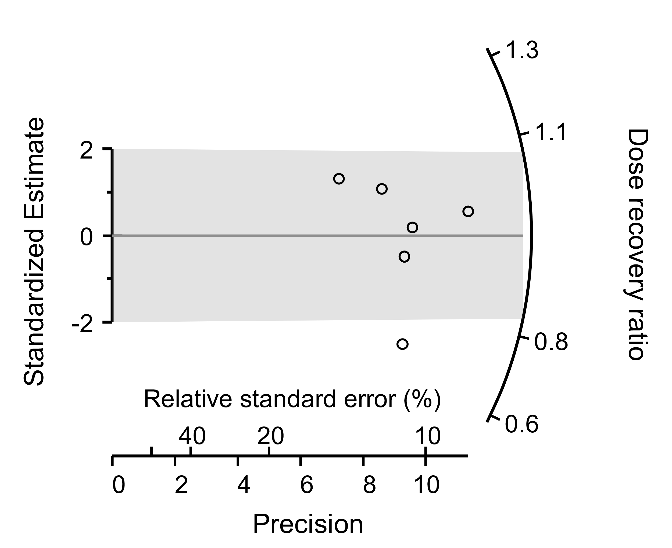
Figure S1: Radial plot of the dose recovery ratio for single aliquots of quartz from Lorrina. The grey lines indicate the (weighted) mean for the dose recovery ratios (CAM), and the grey bar should capture 95% of all measured aliquots if they are statistically consistent at 2σ with a common value, the CAM of the dose recovery ratios in these plots.

Age determination
In total, 41 aliquots of quartz were measured using the protocol shown in Table S2. Most aliquots showed bright rapidly decaying signal intensity that is indicative of the desired thermally-stable “fast” signal component (Figure S2, left). All dose response curves were fitted with a single exponential function (Figure S2, right).

Figure S2: Luminescence decay curves (left side) and dose response curves (right side) for one representative aliquot of Lorrina. The blue curve (panels on left side) shows the decay of the L_{n} signal, and the yellow curve shows the decay curve of a regenerated signal. The panels on the right-side show dose response curves built from multiple regenerated dose points (black squares) and the L_{x}/T_{x} signal projected onto the curve and the x-axis (estimated D_{e} in seconds).The dose response curve was fitted using the first 0.1 s of the signal (first channel) with the background (last 50 channels) subtracted.

Rejection statistics for the Lorinna sample are shown in Table S4. Most of them were rejected due to the L_{n}/T_{n} signal being interpolated onto the growth curve beyond the highest given dose point. Outliers are identified using the “Interquartile Range (IQR)” method which utilizes the median and the first and third quartiles of the aliquot D_{e} distribution to set upper and lower thresholds for D_{e} values to be included in age determination. A D_{e} value (including its uncertainty) outside of the threshold (lower or upper) is classified as an outlier.

Table S4: Single aliquot rejection statistics for the quartz samples from Lorinna, Christmas Hills. Total number of aliquots measured for each sample is summarized in Table 1.
Sample | Lorrina
Extrapolation (D_{e} obtained through extrapolation beyond the last point on the dose response curve) | 7
Recycling ratio outside  ± 10% of unity | 5
Poor fit of DRC | 3
Recuperation >10% | 2
Max. test dose error exceeded 10% | 4
Outlier rejection | 1
Total | 22

The age with the outlier excluded is131 ± 15 ka, and if it is included the age is 143 ± 11 ka (Table 1). Overdispersion is a measure of the variation between individual D_{e} values that is not accounted for by analytical uncertainties. It has been shown that most samples consisting of mostly fully bleached quartz grains (<100 grains per aliquot) have OD values of 20% or less (Galbraith et al. 1999, Lian and Roberts 2006, Jacobs and Roberts 2007). Therefore, an overdispersion of ≤20% is suggested for the application of the Central Age Model (CAM) (Galbraith et al. 1999, Jacobs and Roberts 2007). Overdispersion value for this sample is 47 ± 8%, however, with the single outlier removed the OD drops to 26 ± 6% (within the recommended range for use of the CAM if the analytical uncertainty is considered) (Figure S3).

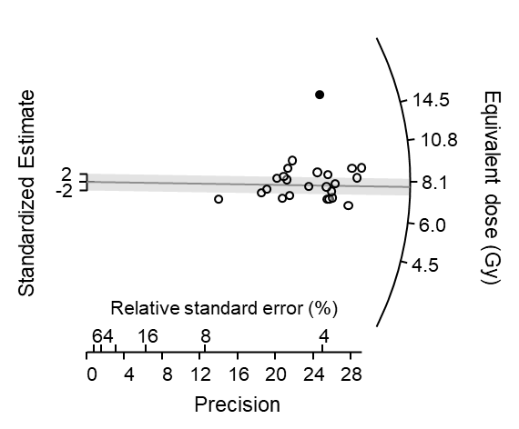
Figure S3: Radial plot of the quartz OSL measurements for single aliquots of quartz from Lorinna. The grey line indicates the (weighted) mean for the D_{e} distributions (CAM), and the grey bar should capture 95% of all measured aliquots if they are statistically consistent at 2σ with a common value. The black filled data points represent aliquots that have been rejected as outliers.

References
Brennan, B.J. 2003. Beta doses to spherical grains. Radiation Measurements, 37: 299–303. doi:10.1016/S1350-4487(03)00011-8.
Galbraith, R.F., Roberts, R.G., Laslett, G.M., Yoshida, H., and Olley, J.M. 1999. Optical dating of single and multiple grains of quartz from Jinmium rock shelter, Northern Australia: Part I, Experimental design and statistical models. Archaeometry, 41: 339–364. doi:10.1111/j.1475-4754.1999.tb00987.x.
Guérin, G., Mercier, N., and Adamiec, G. 2011. Dose-rate conversion factors: update. 29: 4.
Jacobs, Z., and Roberts, R.G. 2007. Advances in optically stimulated luminescence dating of individual grains of quartz from archeological deposits. Evolutionary Anthropology: Issues, News, and Reviews, 16: 210–223. doi:10.1002/evan.20150.
Lian, O.B., and Roberts, R.G. 2006. Dating the Quaternary: progress in luminescence dating of sediments. Quaternary Science Reviews, 25: 2449–2468. doi:10.1016/j.quascirev.2005.11.013.
Liang, P., and Forman, S.L. 2019. LDAC: an Excel-based program for luminescence equivalent dose and burial age calculations. Ancient TL, 37: 21–40.
Murray, A.S., and Wintle, A.G. 2000. Luminescence dating of quartz using an improved single-aliquot regenerative-dose protocol. Radiation Measurements, 32: 57–73. doi:10.1016/S1350-4487(99)00253-X.
Murray, A.S., and Wintle, A.G. 2003. The single aliquot regenerative dose protocol: potential for improvements in reliability. Radiation Measurements, 37: 377–381. doi:10.1016/S1350-4487(03)00053-2.
Wintle, A.G. 1997. Luminescence dating: laboratory procedures and protocols. Radiation Measurements, 27: 769–817. doi:10.1016/S1350-4487(97)00220-5.

